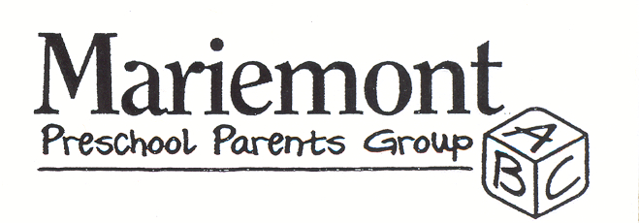

2017-2018 Membership Form
(Online form & payment submission also available at http://www.mariemontppg.com/join)
Please choose your membership type:

- New Member | - Returning Active Member
- Sustaining Member  (Active Member for 5+ Years) | - Alumni Member

1. Parent Member Name: __________________________________________________
2. Parent Member Name:__________________________________________________
Address: _____________________________________________________________
City: ___________________________________ State: _________ Zip: __________
Phone: _________________________________ Cell: _________________________
Email: _______________________________________________________________
Children
Name: ______________________________ DOB: (Month/Day/Year): ___________
Name: ______________________________ DOB: (Month/Day/Year): ___________
Name: ______________________________ DOB: (Month/Day/Year): ___________
Name: ______________________________ DOB: (Month/Day/Year): ___________
Are you expecting? YES NO (Please circle one.) If so, when are you due? __________
Will your youngest child enter kindergarten next fall? YES NO (Please circle one.)
Please confirm your acceptance of the following requirements as outlined in the MPPG
Procedures and Membership Agreement.*
- Members must be parents to children between the ages of birth through preschool (or are expecting).
- Members are required to serve on the annual Luminaria fundraiser committee and one additional committee of their choice.
- Members are required to provide one Meal Baby meal throughout the year.
- Members must pay the annual dues by the date provided at the opening meeting.
Signature: ______________________________________________________________

* Alumni members are exempt from these requirements
* MPPG Procedures and Membership Agreement are available at www.mariemontppg.com

2017-2018 Membership Form
Payment
(Online form & payment submission also available at http://www.mariemontppg.com/join)
Parent Member Name: _________________________________________________
Phone: _________________________________ Cell: _________________________
Email: _______________________________________________________________

MPPG members have the opportunity to make a Meal Baby contribution. This optional contribution fulfills the member’s Meal Baby requirement for the year.

Item | Quantity | Price | Total
2017-2018 MPPG Membership |  | $75.00
2017-2018 MPPG Alumni Membership |  | $10.00
Meal Baby Contribution (optional) |  | $25.00
Grand Total

Please select your method of payment:

- PayPal
* Go to http://www.mariemontppg.com/join
* Processing fee applies
* You will be asked to complete this same form online before submitting payment online

- Check/Cash
* Please make payable to Mariemont Preschool Parents Group (MPPG)

If submitting paper membership form and/or check, please mail or drop off to:
Alandra Parchman, Membership Chair
3847 Miami Road
Cincinnati, OH 45227
Questions? Please contact info@mariemontppg.com

